**Flying Cars**

[**https://breakingnewsenglish.com/2107/210703-flying-car.html**](https://breakingnewsenglish.com/2107/210703-flying-car.html)

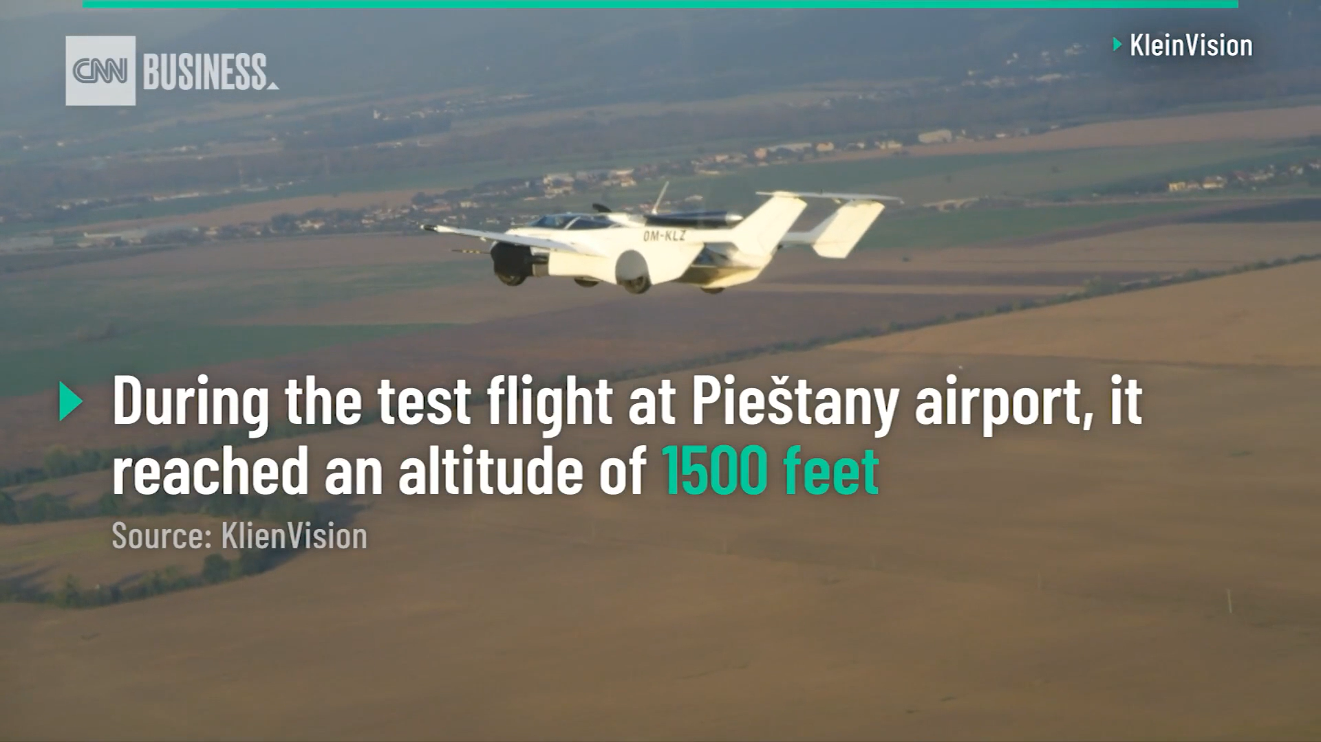

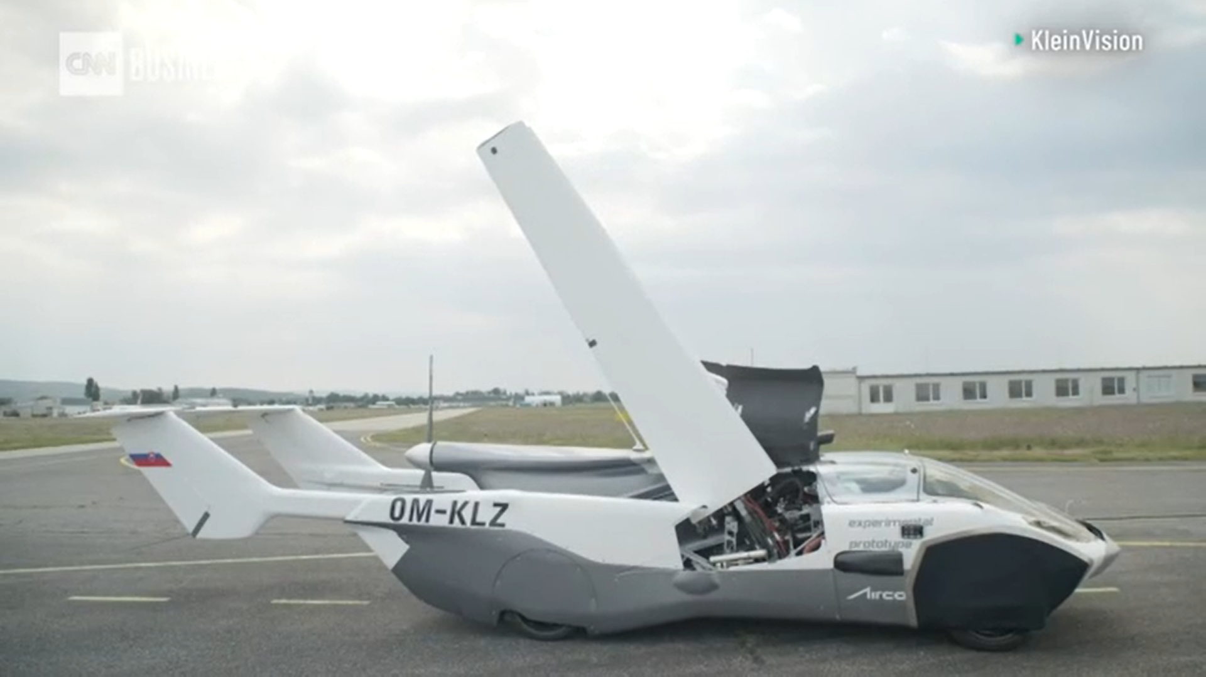

[**https://edition.cnn.com/2021/06/30/business/flying-car-flight-slovakia-scli-intl/index.html**](https://edition.cnn.com/2021/06/30/business/flying-car-flight-slovakia-scli-intl/index.html)

**Listening Task**

**1. Listen for the gist**

**2. Listen for the facts about AirCar Prototype-1 test flight**

Location

Distance of the flight

Duration (time)

Speed

Height

transformation time

number of seats

**3. Read the text and check your answers**

It's hard to keep up with technology these days. The latest example of science fiction becoming science fact is a flying car. For decades, we have watched movies about a future with flying cars. This week, journalists saw a real one in flight. A prototype flying AirCar completed a test flight between two cities in Slovakia. The car flew between a regional airport and an airport in the capital city Bratislava. The 90km journey took 35 minutes to complete. AirCar is from a company called Klein Vision. A founder of the company said: "AirCar is no longer just a proof of concept." He added: "Flying at [2,500 metres] at a speed of [185kph], it has turned science fiction into a reality."

AirCar is a road-legal car that transforms into an aircraft in less than three minutes. AirCar CEO Professor Stefan Klein flew and landed the vehicle on its recent test flight. After landing at Bratislava Airport, he pushed one button to transform the aircraft into a sports car. He then drove it into downtown Bratislava on the city's streets. He described the flight as "normal" and "very pleasant". His company is working on a new, more powerful model called AirCar Prototype 2. This will have a much more powerful engine that is capable of a cruising speed of 300kph and a range of 1,000 kilometers. The newer model will also be a four-seater as opposed to the two-seater that was recently tested.

**Discussion questions**

1. What do you think of the car becoming an airplane in three minutes?
2. How might flying cars be better for cities?
3. Would you worry about getting into a flying car?
4. How can we stop flying cars crashing into each other?
5. Where would you go if you had an AirCar?
6. What kind of training might you need to fly an AirCar?
7. Do you think common people should be allowed to buy AirCars?
8. Do you think AirCars will mean the end of airplanes?
9. When will flying cars be as common as road cars?